Finding your online courses

If you booked onto an online course via uLearn, you will now need to access the course using the Athletics Hub platform.

If you are enrolled on a course that has Knowledge Tests, all your course progress will still be there – nothing has been removed or changed.

To access courses booked via uLearn, please follow the below steps:

- Log in to www.athleticshub.co.uk. Your URN and password to log in will be the same as your uLearn login details.

- Update your contact details and complete all other fields with an asterisk.

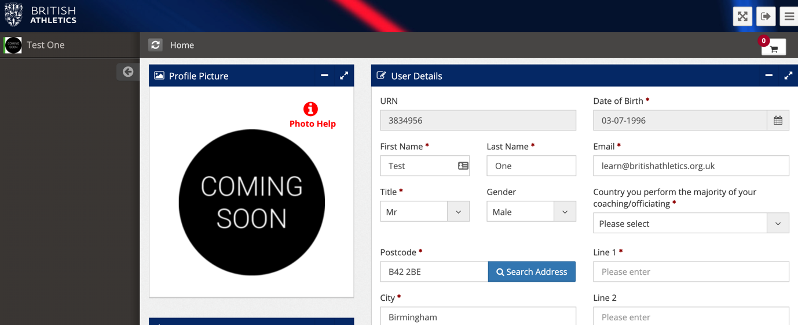

Click ‘Submit’.

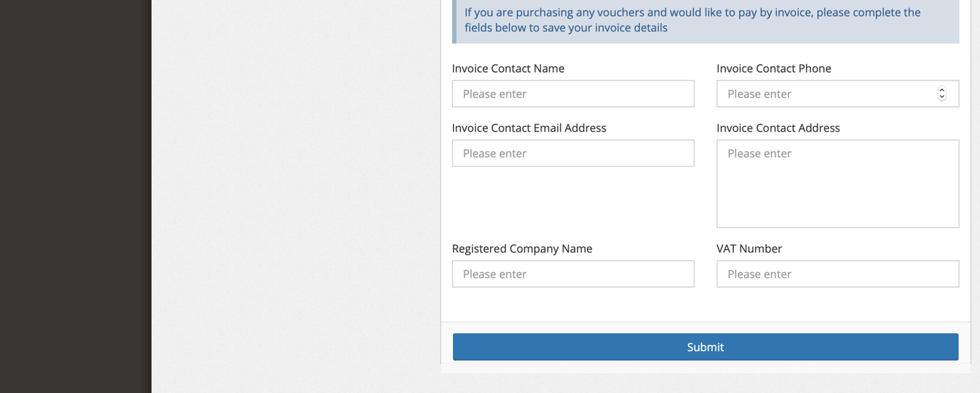

- Expand the ‘Online Courses’ tab.

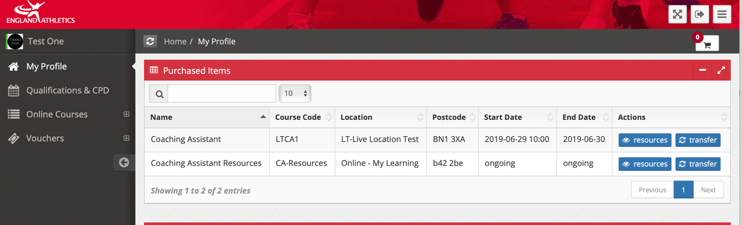

- Click on ‘Go to My Learning:

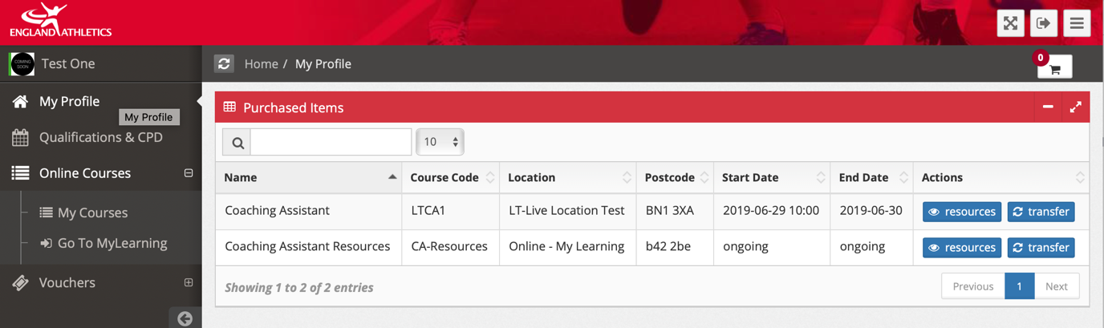

- This will take you through to your My Learning platform. Your course will be listed under the My Courses heading.

